

CS 319 Term Project

Final Report Iteration 2

**Team Name: Group 2H CA**

**Project Name: Settlers of Catan**

**Members:**

• Ravan Aliyev

• Berrak Taşkınsu

• Hazal Aksu

• Ayşe Nursu Savaşkan

Table of Contents

**1.Introduction and Implementation process** **3**

**2.Design changes** **4**

**3.Lessons Learnt** **6**

**4.User’s Guide** **7**

4.1. How to Start 7

4.2.Settings 8

4.3.New Game 9

4.4 Determining turns 10

4.5.Building roads, cities and settlements 11

**5. Build Instructions** **13**

# 1.Introduction and Implementation process

We have started implementing the software after the design. We used JavaFX and Java Swing to develop the software. We started by assigning tasks to everyone in the group according to their interests.This made our work more efficient since everyone chose the topics they are familiar with. Firstly we decide which parts are harder and divide these parts between group members equally. We have completed Menu including “How To Play”, “Credits”, “Settings” and “Play” menus. In Game Play screen “Players”, “Bank”, “Board”, “Cards”, “Trade Off”, “Build” are completed. Players can enter name and choose color to start the game. Bank keeps cards in order to distribute to players or get cards back from them when needed. Board contains hexagonal pieces where cities, settlements, roads and thief can be placed accordingly. Cards are designed and divided into two parts: resource and development cards. “Trade Off” screen enables players to exchange cards with other players. Build screen enables players to build roads, cities or settlements. All of these listed above are completed, but still there are some problems which is needed to be fixed. For example, before switching between panes some conditions need to be met, but in our software these conditions are not implemented yet. Examples to these conditions can be players are not allowed to choose same color and player can not start game without entering game.

# 2.Design changes

After the Design report we found out that some classes and methods are unnecessary. We decided how to fix it during group meeting and redesign those parts accordingly. Another thing that we found out that some classes does not contain needed methods. Also, another problem was connection between some classes. All of the problems were fixed during implementation. Since English is a global language we decided adding new languages is unnecessary for now and we will not implement language selection part in Setting menu, but we can add this feature in the future if needed. We also decided not to implement color blind mode option which was planned to be provided in Setting menu. Because, we decided to use color blind friendly visualizations in our software and there will be no need to choose this mode optionally. The most important change is we decided to apply “Model View Controller” architectural pattern. Diagrams given below show how this pattern is implemented in our system:

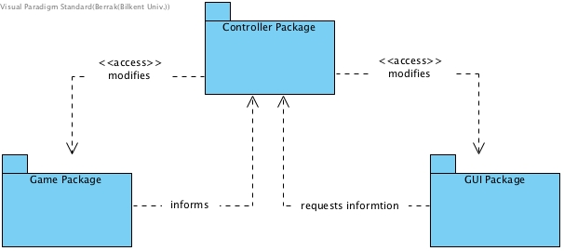

*Figure 1: Packages Overview*

The interactions between the model elements and the view elements occur through the Controller classes.

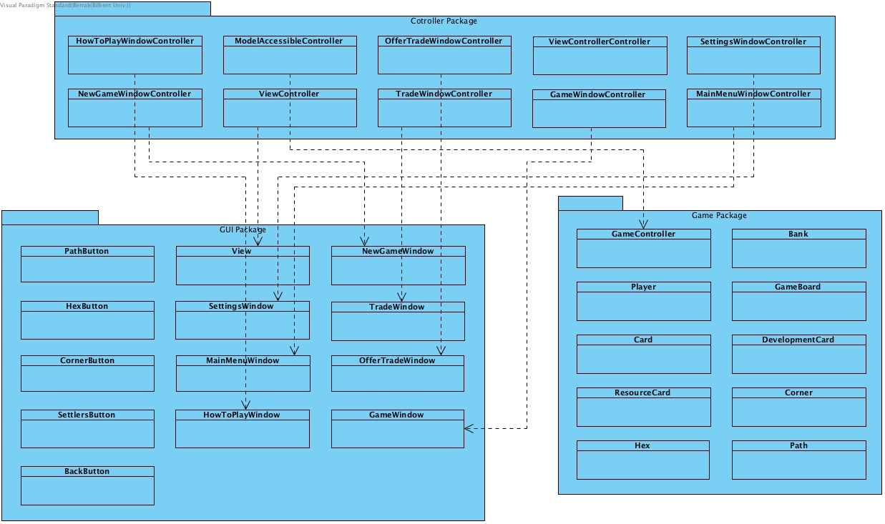

*Figure 2: Packages*

# 

# 

# 

# 

# 

# 3.Lessons Learnt

This project has taught us how software engineering work in real life. It helped us to understand the importance of communication for the project. We scheduled meetings to discuss the design of the software, tasks and problems that we faced during implementation. Social media also were used for communication, whatsapp group for asynchronous communication and Skype for synchronous communication. Another thing that we learnt from this project is the importance of Analysis and Design Report. These reports helps divide and conquer the project by reducing complex tasks into more simpler parts. Design and Analysis reports allows us to see the big image of project before the development process. While implementing this software we saw that it worths to invest time in writing Analysis and Final Reports. We are group of 4, which is a very small number compared to real world project groups and other groups in the course and this caused to have too much amount of workload but we tried our best and these reports and planning before implementation process helped us overcome the obstacles that we encountered while implementation.

# 

# 4.User’s Guide

## 4.1. How to Start

Main Menu is the first screen that user sees when the software is started. Users can choose different options in the Main Menu, like New Game, Settings, How To Play and quitting game.

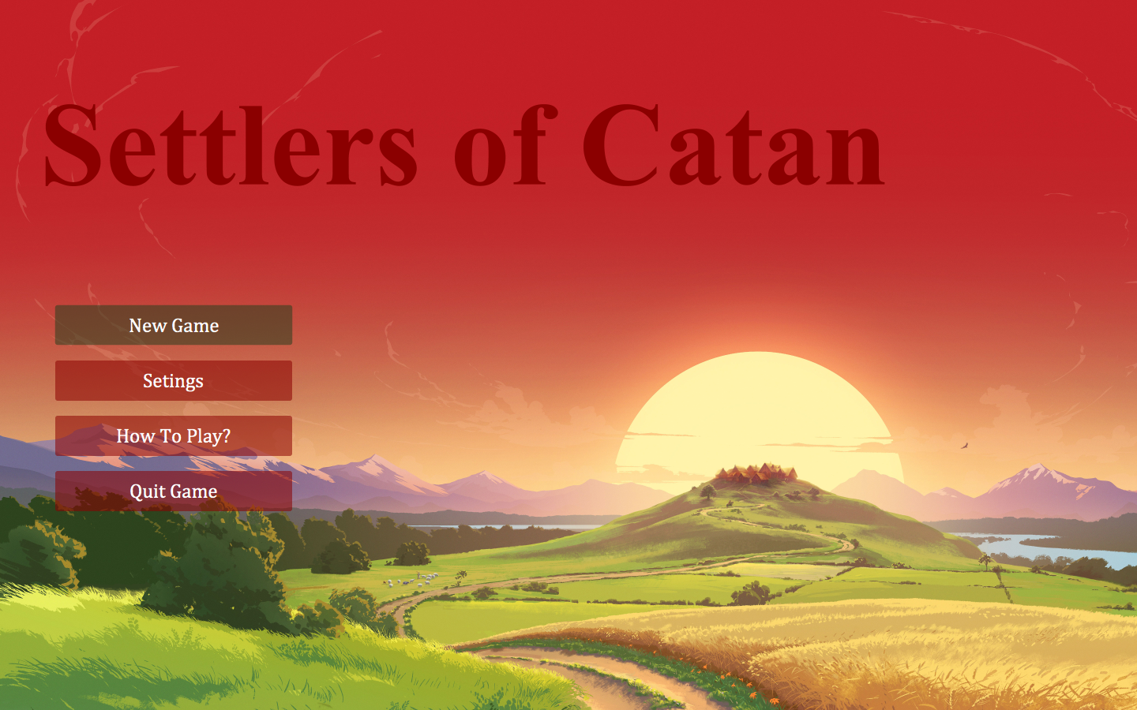

*Figure 3. Main Menu*

## 4.2.Settings

Players can get to Setting menu from Main Menu, and they can change different settings of the game like language, music and color blindness mode.

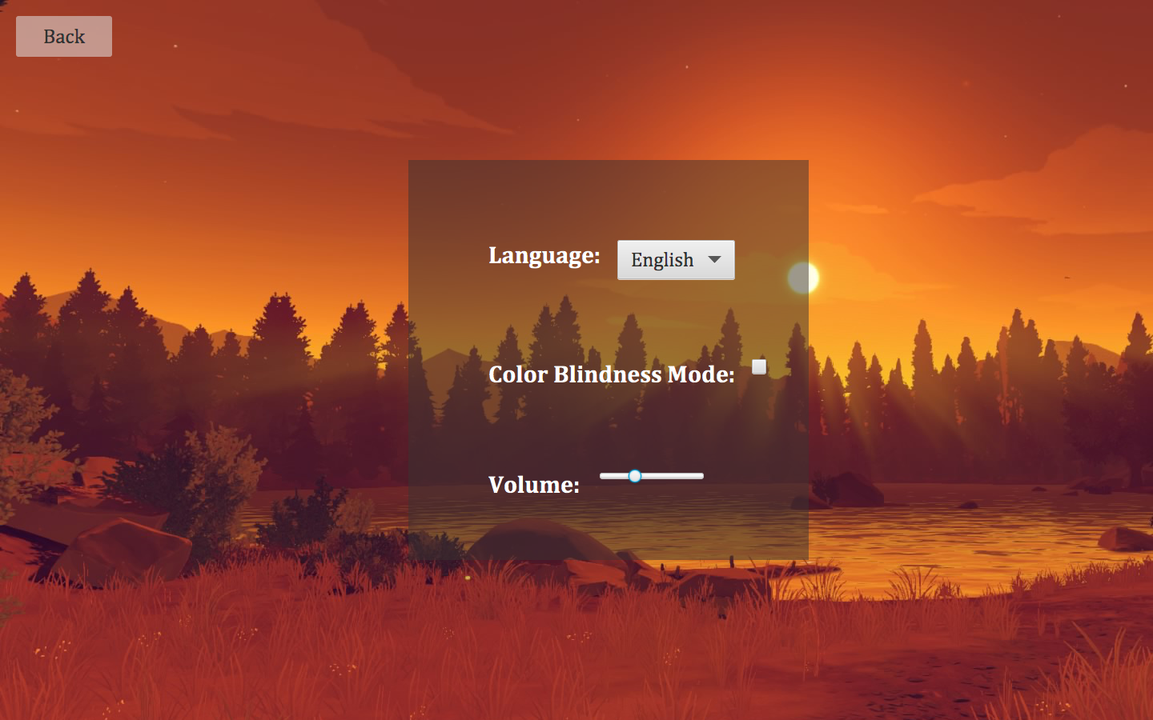*Figure 4. Settings Menu*

## 

## 

## 

## 4.3.New Game

Users can get to this screen from Main Menu by clicking on New Game and start playing game. First of all, enough number of players should be added by choosing their colors and entering names.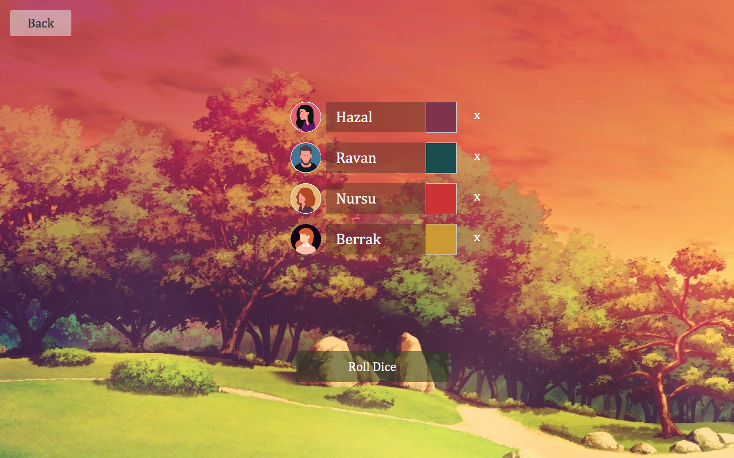

*Figure 5. Adding Players*

## 

## 

## 4.4 Determining turns

After adding enough number of players, every player rolls dice. Players will be ordered after rolling dices according the number they have rolled.

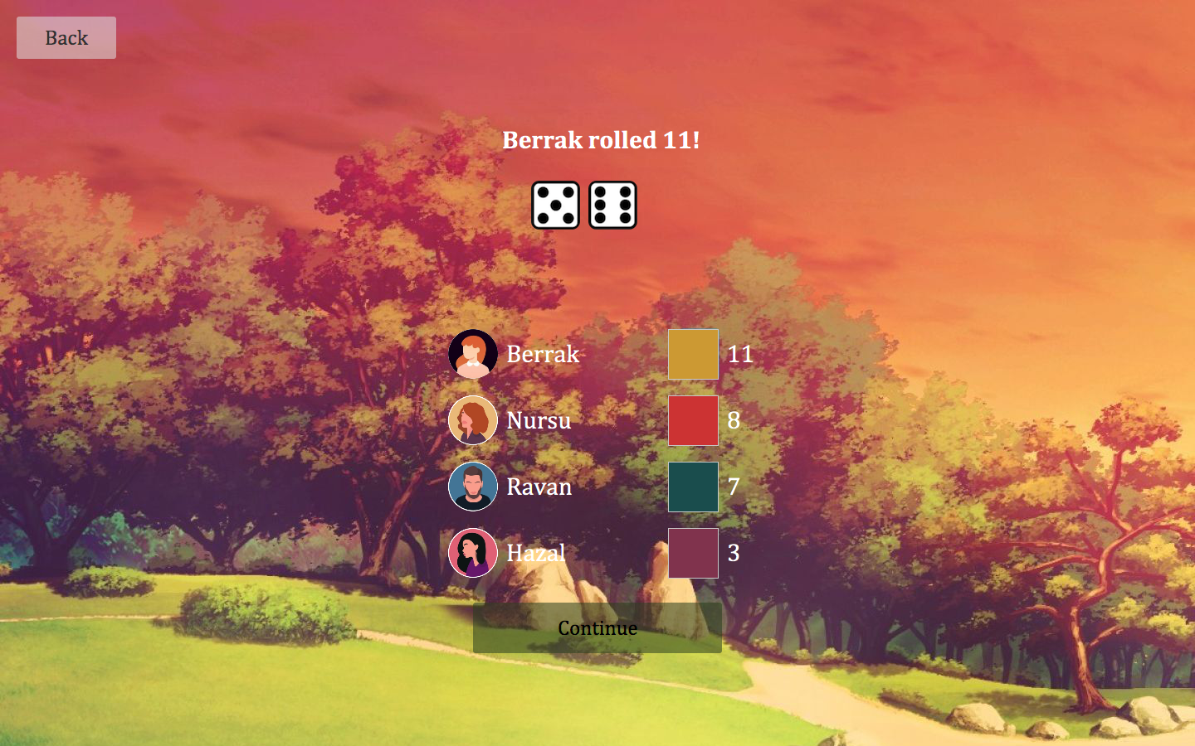

*Figure 6. Determining Turns Screen*

## 

## 

## 

## 4.5.Building roads, cities and settlements

Every player can build a city, road and settlement during their turn. Green color near player’s icon indicates whose turn it is.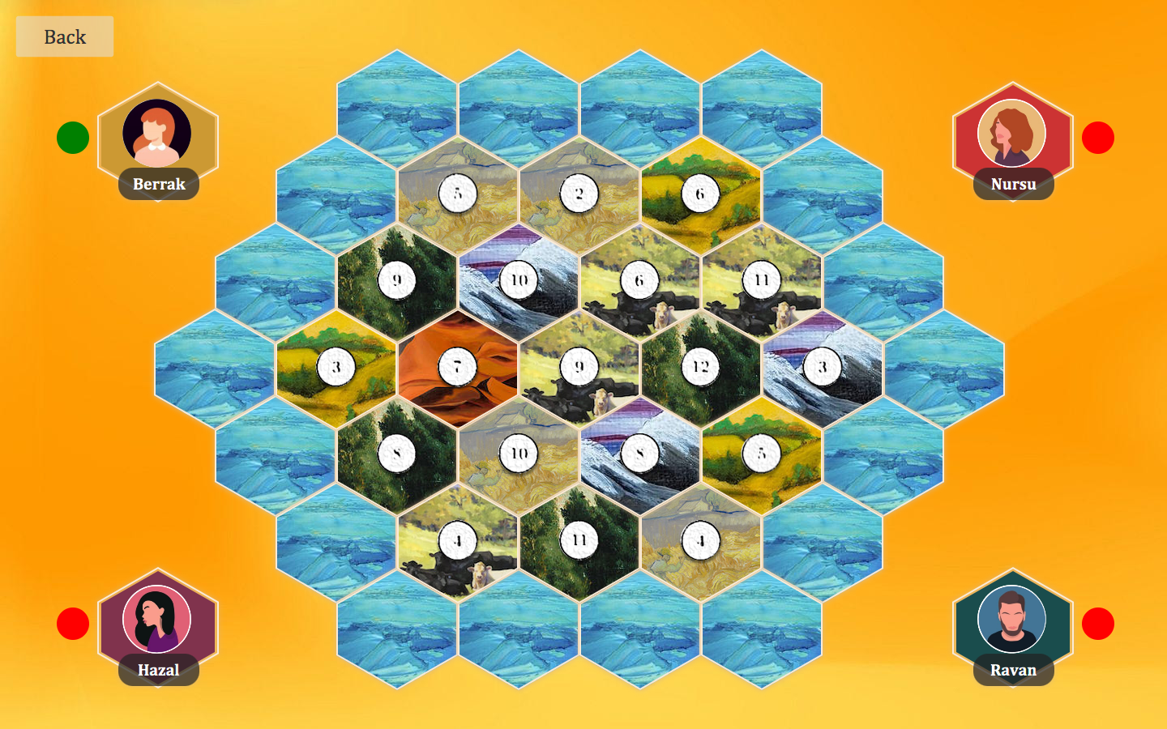

*Figure 7. Green color indicating whose turn it is*

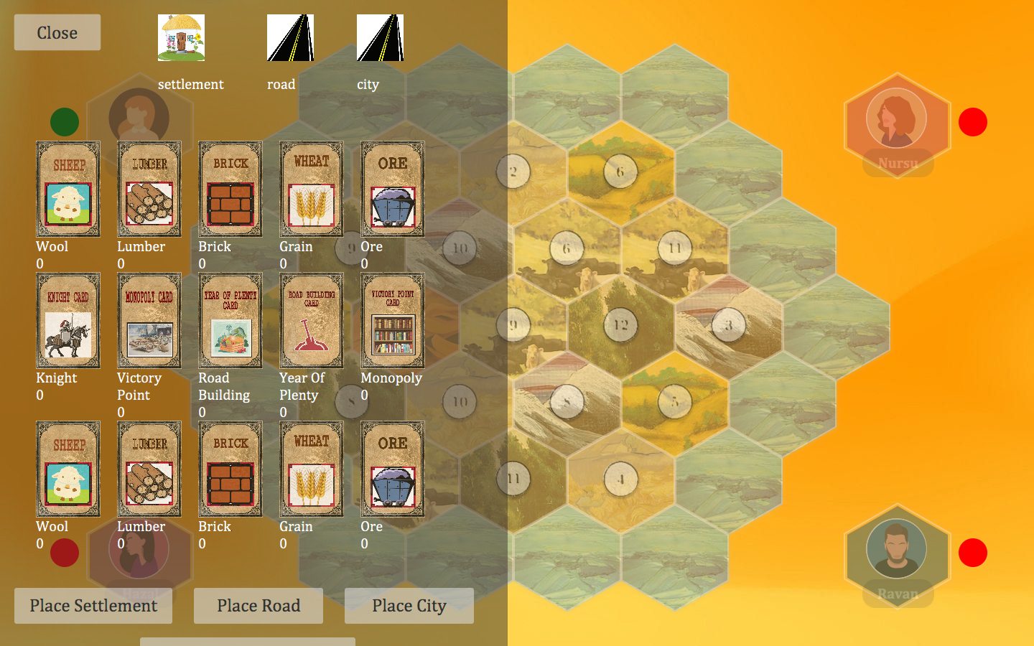*Figure 8. Screen for building pieces and displaying cards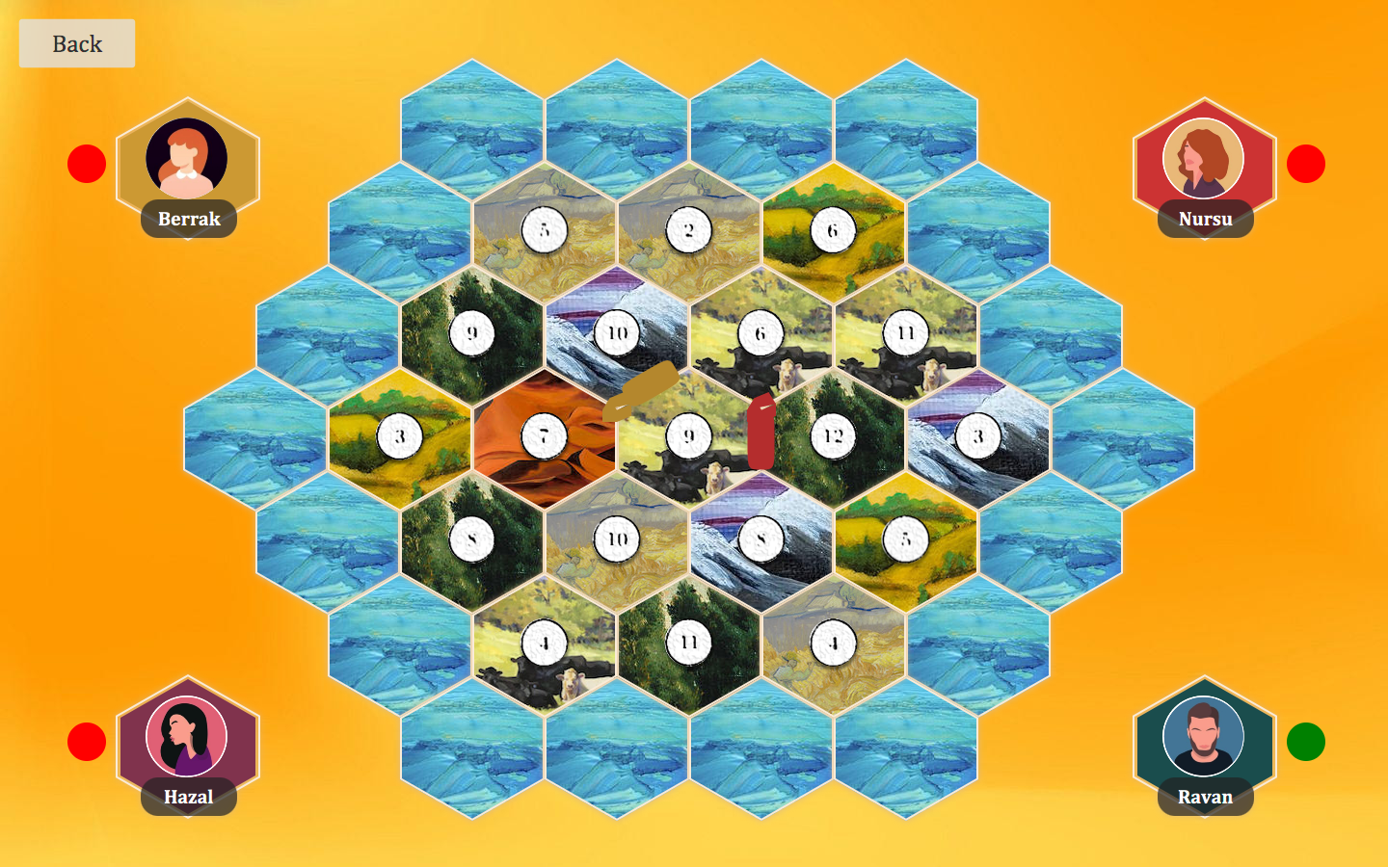Figure 9. Game Board after placing road and settlement*

# 5. Build Instructions

This game does not need any installation. It will be public as a “.jar” file, which will make it enable to everyone and cause to the game to be platform independent. This game can be played on every device that supports JRE 8. It can be installed on Windows, Mac OS and Linux operating systems and it was the main reason for making the game available as .jar file.

1. The .jar file will be available in our github repository and everyone can download it by going to our github repository: <https://github.com/berraktaskinsu/CS319-2H-CA>
2. Or everyone can download our source codes and run it from compiler. To do so, users need to clone the project via command line or bash or Download the project as a ZIP file and run it in any Java Compiler (for example, IntelliJ, Eclipse etc.)
3. User can learn the game by reading informations provided in “How To Play” screen
4. Users can go to “Credits” screen and get information about the developers of the software
5. To get more information about our software design and implementation, reports are available in our github repository